# **Name: Abdurrahman Qureshi**

# **Roll No: 242466**

Practical No: 5

Execution of process, disk, network commands

Process Commands:

**1) ps**

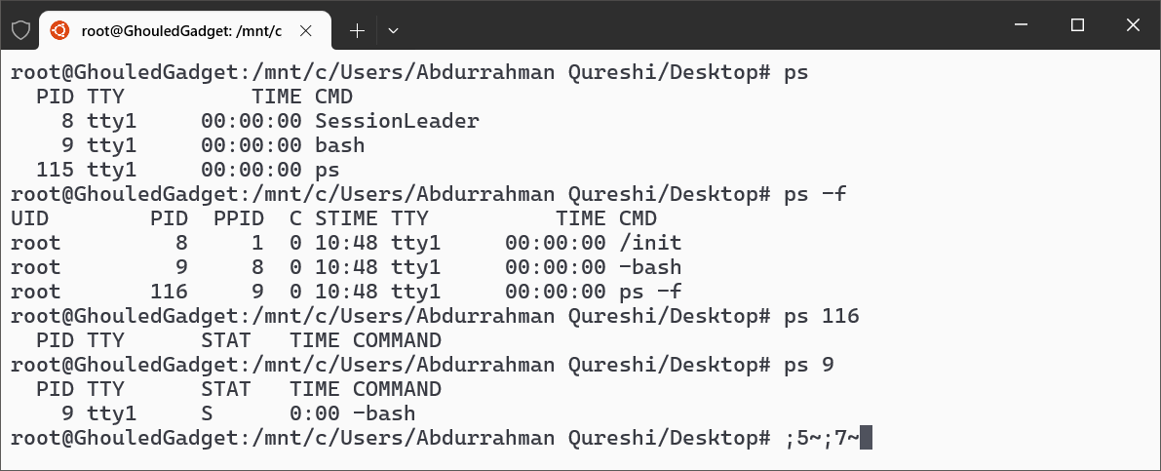

**2) kill**

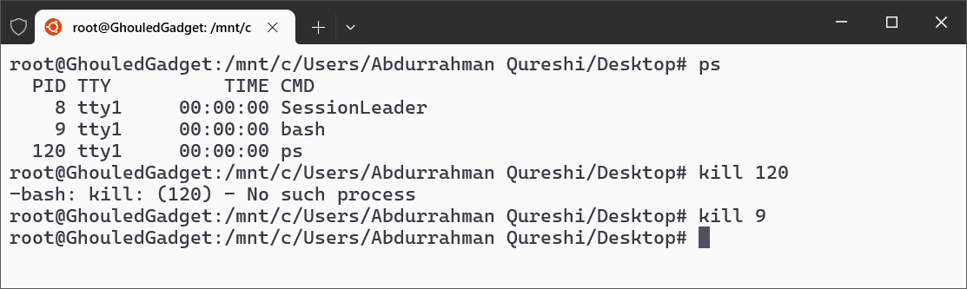

Disk Commands:

**3) du**

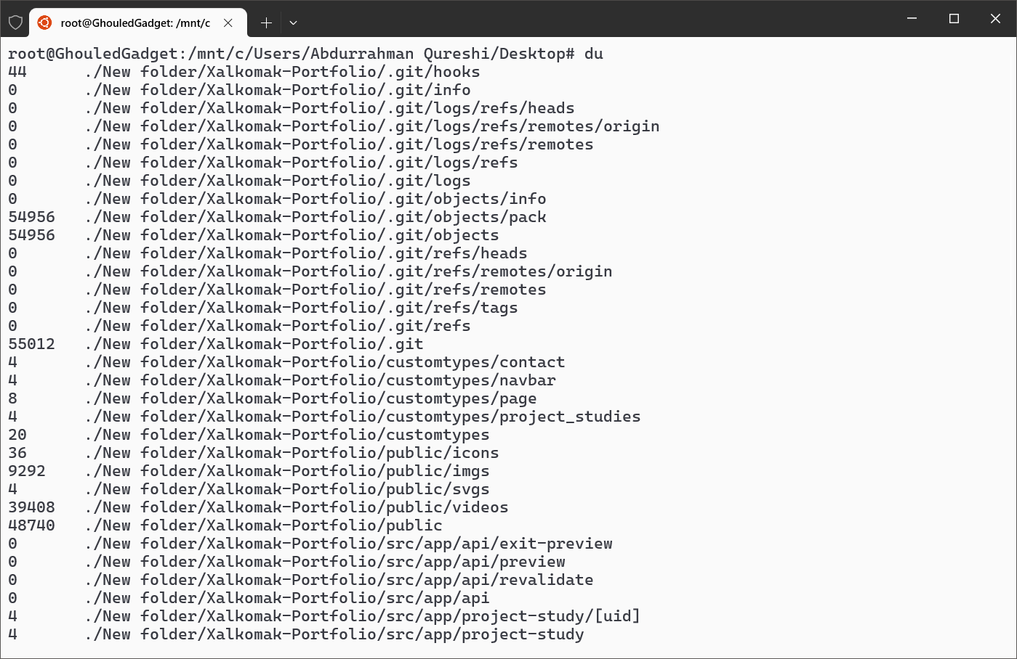

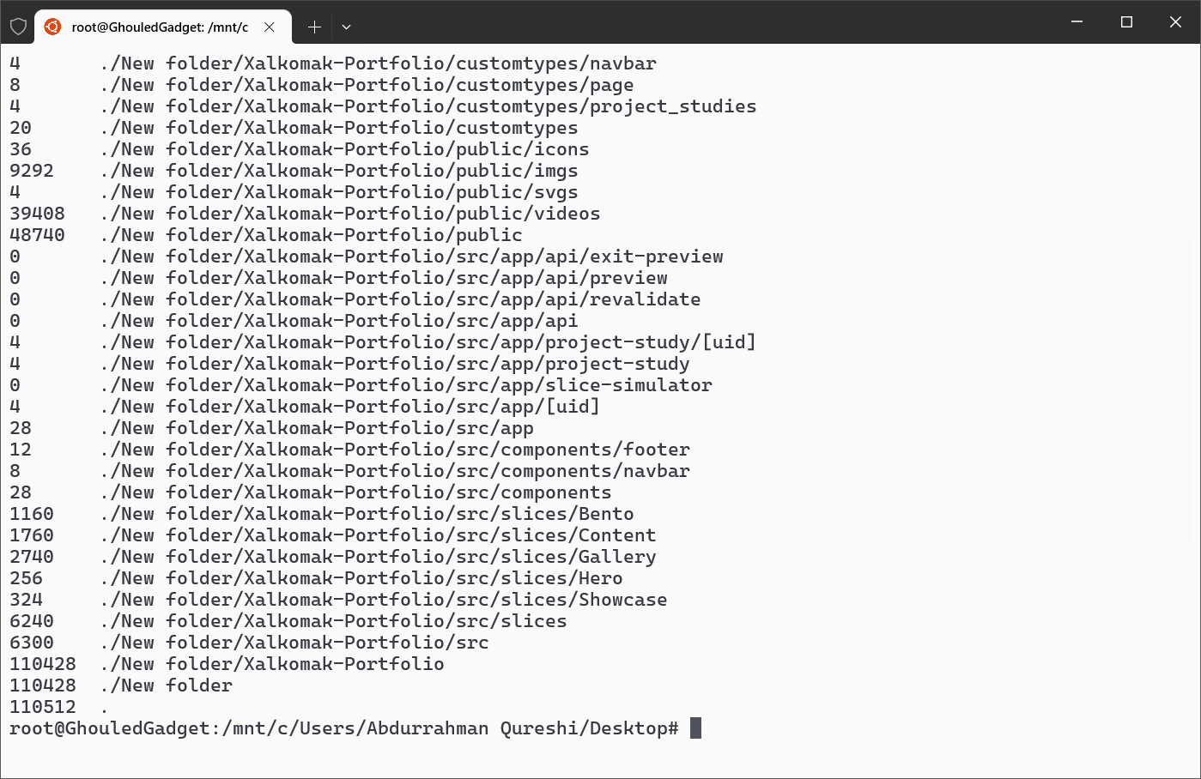

**4) df**

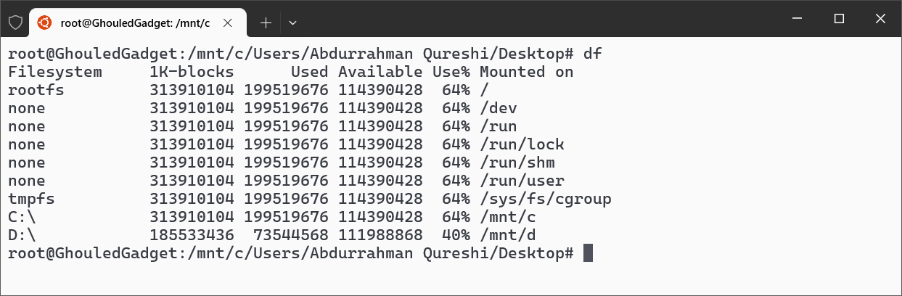

Network Commands:

**5) ifconfig**

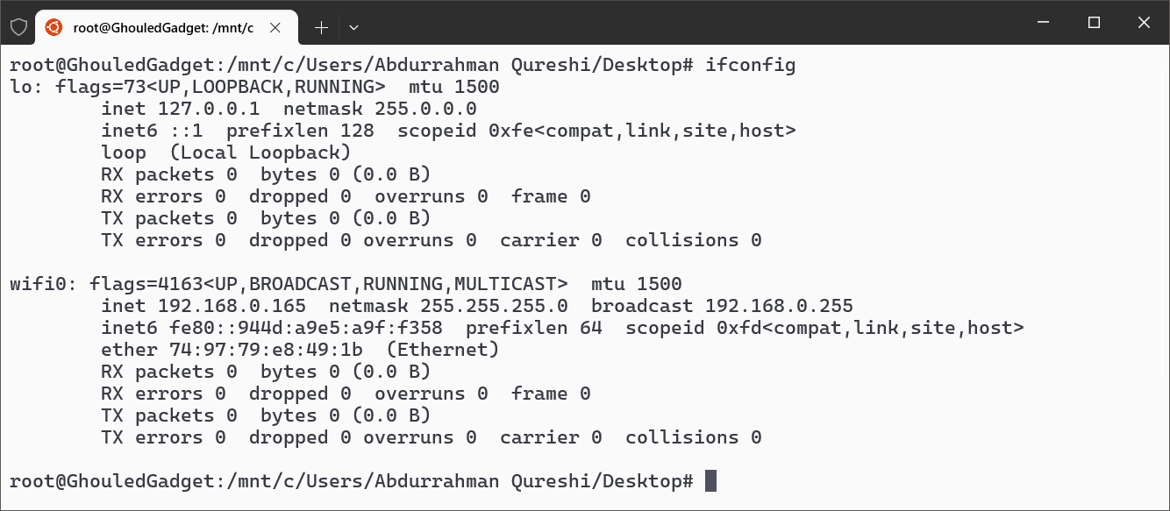

**6) w**

